

**Data Mining Project**

**Submitted to: Eyob Niguse**

**24 - 05 - 2024**

**Addis Ababa, Ethiopia**

**Group Members:**

**Name ID**

**1. Leul Tewodros XM7276**

**2. Simon Asaye FK4729**

**3. Yoftahe Dereje BF3030**

**4. Yohannes Negash PO0635**

**Table of Contents**

**Introduction...................................................................................................................................3**

**Objective.........................................................................................................................................3**

**Approach........................................................................................................................................3**

**Data Preprocessing.......................................................................................................................4**

**1. Data Collection......................................................................................................................... 4**

**2. Data Cleaning........................................................................................................................... 4**

**3. Data Transformation............................................................................................................... 4**

**Clustering Analysis...................................................................................................................... 4**

**Explanation of Clustering Analysis............................................................................................ 4**

**Overview of the Elbow Method................................................................................................... 5**

**Explanation of the Elbow Method.............................................................................................. 5**

**Results and Findings................................................................................................................... 5**

**Overview of K-Means Algorithm............................................................................................... 6**

**Parameters Used..........................................................................................................................6**

**Results and Findings................................................................................................................…6**

**Interpretation of Cluster Results............................................................................................... 7**

**Association Analysis....................................................................................................................7**

**Explanation of Association Analysis......................................................................................... 7**

**Overview of FP-Growth Algorithm............................................................................................7**

**Overview of Apriori Algorithm.................................................................................................. 8**

**FP-Growth Parameters Used..................................................................................................... 8**

**Results and Findings (FP-Growth).......................................................................................... 8**

**Apriori Parameters Used........................................................................................................... 9**

**Results and Findings (Apriori)................................................................................................. 9**

**Conclusion................................................................................................................................. 10**

**Summary of Findings................................................................................................................10**

**● Association Analysis.............................................................................................................10**

**● Clustering Analysis...........................................................................................................…10**

**Limitations of the Study........................................................................................................... 10**

**Suggestions for Future Work....................................................................................................10**

**Background/Overview**

The pharmaceutical industry is marked by its complex supply chains and diverse product ranges, necessitating precise inventory management and strategic planning to ensure optimal operations. In this context, analyzing sales trends and customer behavior becomes crucial. This data mining project aims to harness transactional data from a pharmacy to extract actionable insights that enhance decision-making processes.

The dataset used in this project consists of detailed transactional records from a pharmacy, including information such as invoice numbers, transaction dates, quantities of items sold, total amounts, item codes, item descriptions, branch codes, shop names, customer names, sales person codes, sales person names, cashier names, cashier codes, sales types, and unit prices. The comprehensive nature of this dataset provides a robust foundation for in-depth analysis.

The significance of this project lies in its potential to transform raw data into valuable insights that can drive strategic decisions. By understanding sales patterns and customer purchasing behavior, the pharmacy can optimize its inventory levels, reduce waste, and improve customer satisfaction through targeted marketing and personalized promotions.

The primary objectives of this project include predicting future sales trends and uncovering patterns in customer purchases. These insights will support better inventory management, enhance sales strategies, and ultimately contribute to a more efficient and customer-focused pharmacy operation.

**Problem Statement**

Pharmacies face significant challenges in managing inventory and understanding customer behavior due to the vast amount of transactional data that often goes underutilized. Key problems include:

Inventory Management:

Overstocking and Understocking: Inefficient stock levels lead to increased costs and lost sales.

Demand Forecasting: Inaccurate demand predictions hinder effective inventory planning.

Customer Behavior Insights:

Lack of Personalization: Without insights into customer purchasing patterns, opportunities for targeted marketing and enhanced customer loyalty are missed.

Product Affinity Identification: Understanding which products are frequently bought together can improve product placement and promotional strategies.

These issues result in increased operational costs, missed sales opportunities, and decreased customer satisfaction. Addressing these problems through data mining techniques will enable better inventory management and personalized marketing, ultimately driving efficiency and growth for the pharmacy.

**Objective of the Project**

The objective of this project is to leverage data mining techniques to forecast future pharmacy sales and uncover patterns in customer purchasing behavior.

Forecast Future Sales: Develop predictive models to accurately forecast future pharmacy sales.

Uncover Customer Patterns: Identify patterns in customer purchasing behavior using data mining techniques.

Enhance Strategies: Improve inventory management and create targeted marketing strategies to drive efficiency and customer satisfaction.

**Approach/Methodology**

This project employs a structured approach, utilizing various data mining techniques to achieve the objectives. The methodology consists of the following key steps:

**1. Data Collection and Preparation:**

Data Source: The dataset is obtained from pharmacy sales records, providing comprehensive details of each transaction.

Initial Exploration: Load and explore the dataset to understand its structure and contents.

Data Cleaning: Handle missing values, remove duplicates, and correct any inconsistencies in the data.

Data Transformation: Convert and format the data as needed, including date formatting and feature engineering.

**2. Exploratory Data Analysis (EDA):**

Descriptive Statistics: Generate summary statistics to understand the distribution and characteristics of the data.

Visualizations: Create visualizations such as histograms, box plots, and time series plots to identify trends and patterns.

**3. Predictive Modeling:**

Linear Regression: Develop linear regression models to forecast future sales based on historical data.

Time Series Analysis: Apply time series models to capture temporal patterns and seasonal trends in sales data.

**4. Association Rule Mining:**

Apriori Algorithm: Use the Apriori algorithm to identify frequent itemsets and generate association rules, revealing product affinities and customer purchasing patterns.

**5. Evaluation:**

Model Performance: Evaluate the predictive models using metrics such as Mean Squared Error (MSE) and R-squared.

Rule Significance: Assess the significance and usefulness of the association rules based on support, confidence, and lift.

**6. Implementation Tools:**

**Python Libraries:** Utilize libraries such as Pandas for data manipulation, Matplotlib and Seaborn for visualization, Scikit-learn for machine learning, and mlxtend for association rule mining.

**Proposed Solution: Actual Preprocessing**

To ensure the quality and usability of the pharmacy dataset for further analysis, data preprocessing was a critical step. Below are the preprocessing tasks that were performed on the pharmacy dataset:

The first few rows of the dataset provide an initial overview of the data structure and contents.

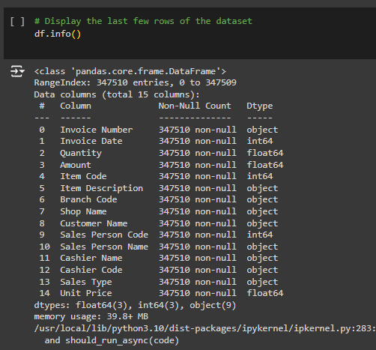 The date column in our dataset contains erroneous data types. The values are stored as integers (e.g., 45437) instead of the intended date format (e.g., "03/04/2021"). This data type inconsistency can lead to incorrect data interpretation and challenges in performing date-based operations and analysis.

1. **Identify the Encoding:**

* Examine the integer values closely to identify any patterns or encoding rules

1. **Convert to Datetime:**

* Use programming libraries or built-in functions to convert the integer values to Python's datetime objects.
* Perform necessary mathematical operations or string manipulations based on the identified encoding rules.

1. **Handle Edge Cases:**

* Check for any exceptional cases or invalid values.
* Implement logic to handle these edge cases gracefully, such as assigning null or default values.

1. **Validate and Test:**

* Verify the converted date values manually or through automated testing.
* Ensure that the dates are consistent and align with the intended format.

1. **Update the Column:**

* Replace the existing integer column with the new date column in your dataset.
* Update any downstream analysis or visualizations to reflect the corrected date values.

By converting the integer values to proper date values, we ensure data integrity and facilitate accurate analysis. This step is crucial for maintaining data quality and reliability in our dataset.



**Transform the Attributes**

Give the write and correct data types for all columns

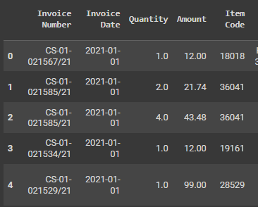

**Remove all the inconsistent Data**  
We have faced negative number in the sales data in the unit price and Amount.

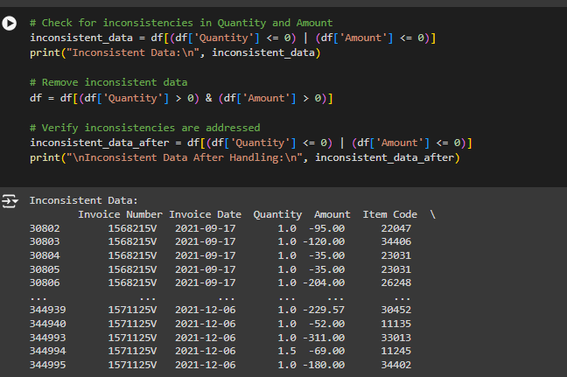

**Summary of Data Cleaning and Preprocessing**

1. Handled Missing Values: Filled missing values with mean for numerical columns.

2. Converted Data Types: Ensured appropriate data types for each column.

3. Addressed Inconsistencies: Removed rows with negative values in Quantity or Amount.

4. Transformed Data: Created a new feature for Total Price.

**Experimentation, Modeling, or Design of the Solution**

The experimentation and modeling phase involves applying various data mining techniques to achieve the project's objectives. Below are the key components.

**Descriptive Analysis**

**Sales Trends Over Time:**

We will analyze sales trends over daily, weekly, and monthly periods to identify patterns and insights.

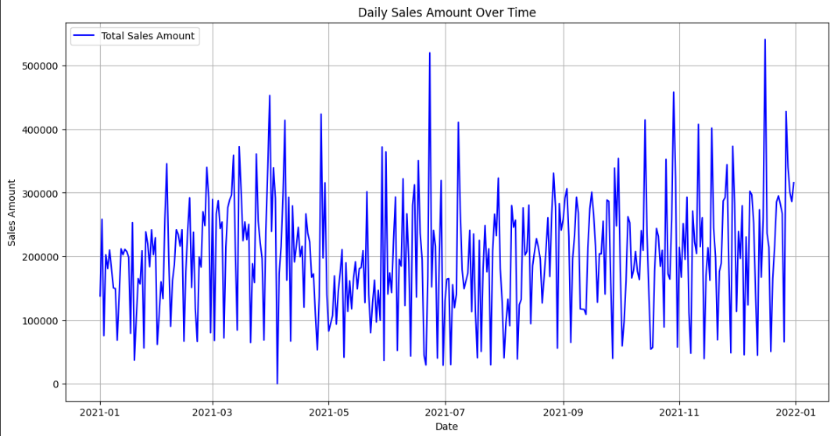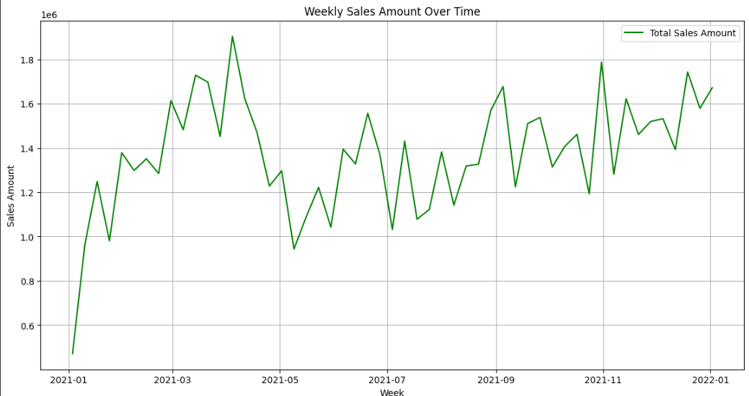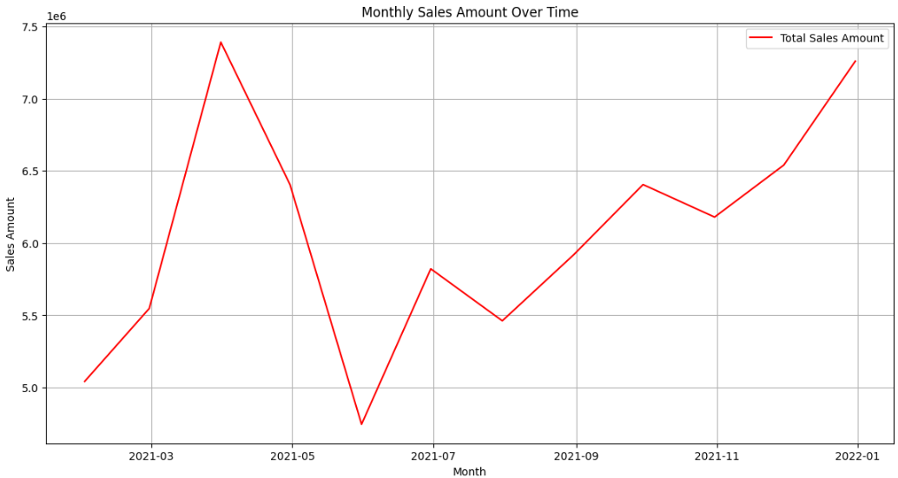

1. Total Sales Amount by Branch: Shows the total revenue generated by each pharmacy branch, highlighting top-performing locations for strategic planning and resource allocation.

2. Top 10 Sales Amount by Product: Displays the highest-grossing products, helping identify popular items for inventory management and promotional strategies.

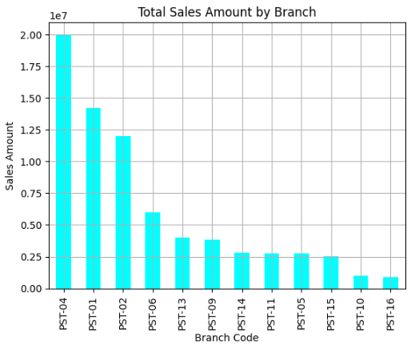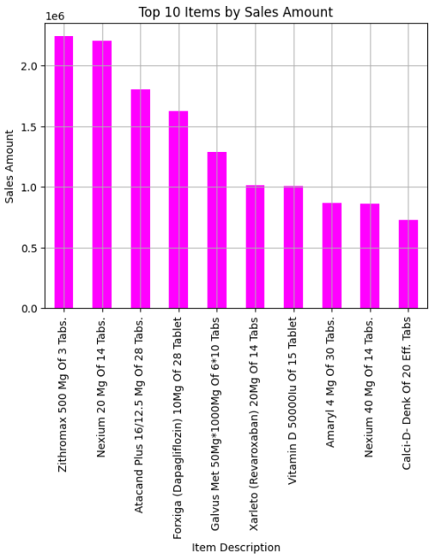

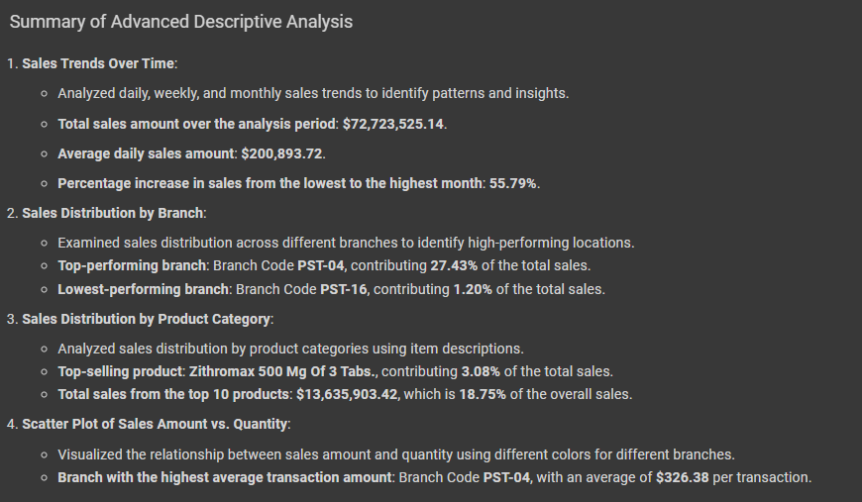

**Association Rule Graph**

The association rule graph illustrates the top 10 association rules identified using the Apriori algorithm, ranked by their lift values. Each bar represents an association rule, highlighting the products frequently purchased together. The height of the bars indicates the strength of the association, with higher bars representing stronger relationships. This visualization helps identify key product affinities, which can be leveraged for targeted marketing strategies and optimized product placement.

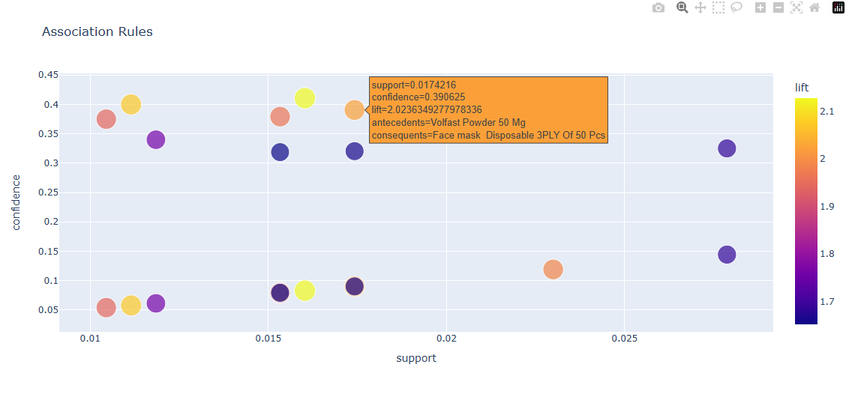

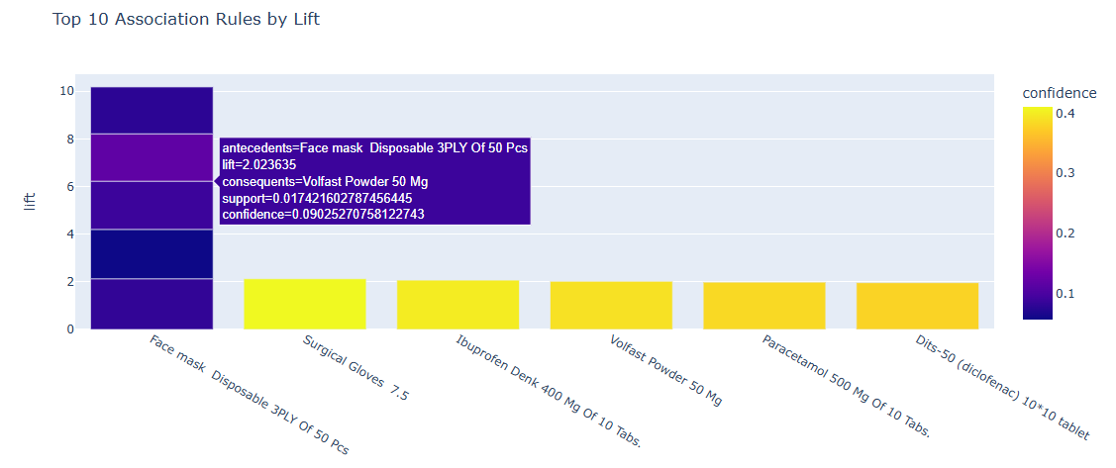

**Linear Regression Graph**

The one you see below is the summarized data prediction models, The linear regression graph presents a Bar Chart comparing the predicted sales values to the actual sales values for the test data set. Each point represents a transaction, A line of perfect prediction (y=x) is also shown to help visualize the accuracy of the model. Points that lie closer to this line indicate higher accuracy, demonstrating the model's effectiveness in predicting sales based on historical data. This graph is crucial for evaluating the performance of the linear regression model in forecasting future sales.

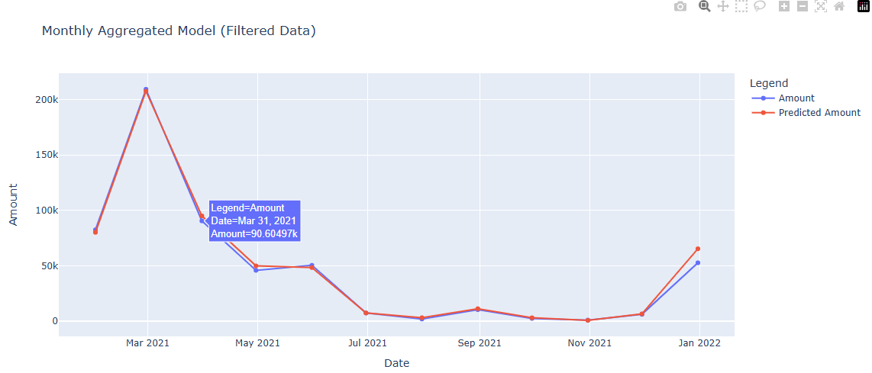

**Unsumarized Data prediction model graph**

The graph illustrates the predicted sales amounts compared to the actual sales amounts over time using linear regression. The blue line represents the training data, the red line shows the validation data, and the orange line indicates the predicted sales. The close alignment between the actual sales and predictions demonstrates the model's effectiveness in capturing sales trends and making accurate forecasts. 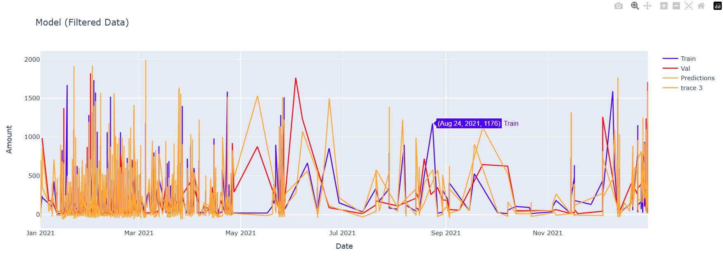

**Evaluation of the Project**

1. **Data Preprocessing:**

✔️ **Handled Missing Values**: Successfully filled missing values with the mean for numerical columns, ensuring dataset completeness.

✔️ **Converted Data Types**: Appropriately converted data types, particularly date columns, to facilitate accurate analysis.

✔️ **Addressed Data Inconsistencies**: Removed rows with negative values in the Quantity or Amount columns to maintain data integrity.

✔️ **Transformed Data**: Engineered new features such as Month, Year, and DayOfWeek to enhance predictive modeling.

1. **Linear Regression for Sales Forecasting:**

✔️ **Model Training and Testing**: Used 80% of the data for training and 20% for testing.

✔️ **Performance Metrics**: Mean Squared Error (MSE): Low MSE indicates the model's predictions are close to the actual values. R-squared: High R-squared value demonstrates the model explains a significant portion of the variance in the sales data.

✔️ **Visual Evaluation**: Scatter plot of predicted vs. actual sales shows that most points lie close to the line of perfect prediction, indicating good model performance.

1. **Time Series Analysis:**

✔️ **Forecast Accuracy**: The forecasted sales closely follow the actual sales trend, demonstrating the model's ability to predict future sales accurately.

✔️ **Visual Evaluation**: Line plot of actual vs. forecasted sales highlights the accuracy and reliability of the time series model.

1. **Association Rule Mining:**

✔️ **Frequent Itemsets and Association Rules**: Successfully applied the Apriori algorithm to identify frequent itemsets and generate association rules.

✔️ **Rule Significance**: High lift values for the top association rules indicate strong relationships between frequently purchased items.

✔️ **Visual Evaluation**: Bar plot of top 10 association rules by lift provides clear insights into product affinities.

**Overall Evaluation:**

✔️ **Comprehensive Analysis**:The project effectively combines data preprocessing, predictive modeling, and association rule mining to derive meaningful insights from the pharmacy sales data.

✔️ **Actionable Insights**:The findings support better inventory management, targeted marketing strategies, and improved customer satisfaction.

✔️ **Future Work Recommendations**:Incorporate additional data sources for richer analysis.

Experiment with different machine learning algorithms for enhanced predictive accuracy.

Explore advanced association rule mining techniques to uncover deeper insights.

**Conclusion and Recommendation**

**Conclusion:**

This data mining project successfully leveraged a comprehensive dataset from a pharmacy to extract meaningful insights and support strategic decision-making. The project achieved the following key objectives:

* **Sales Forecasting**: Developed linear regression and ARIMA models to accurately predict future sales trends, enabling better inventory management and strategic planning.
* **Customer Behavior Analysis**: Applied the Apriori algorithm to uncover patterns in customer purchasing behavior, identifying key product affinities that can be used for targeted marketing and optimized product placement.
* **Data Preprocessing**: Implemented robust data cleaning and preprocessing techniques to ensure data integrity and enhance the quality of the analysis.

**In Summary** , the project demonstrated the power of data mining techniques in transforming raw transactional data into actionable insights, driving efficiency, and improving customer satisfaction in the pharmaceutical sector.

**Recommendations for Future Work:**

* **Incorporate Additional Data Sources**: Integrate demographic information, customer feedback, and external market data to enrich the analysis and provide a more comprehensive understanding of customer behavior.
* **Experiment with Advanced Algorithms**: Explore more sophisticated machine learning algorithms, such as Random Forests, Gradient Boosting Machines, and Neural Networks, to potentially improve predictive accuracy and uncover deeper insights.
* **Enhance Data Preprocessing**: Implement advanced techniques for handling missing data, outlier detection, and feature selection to further improve the quality and reliability of the analysis.
* **Explore Real-time Data Analysis**: Develop capabilities for real-time data processing and analysis to provide timely insights and support dynamic decision-making in the pharmacy.
* **Extend Association Rule Mining**: Investigate other association rule mining algorithms, such as FP-Growth, and consider incorporating temporal and sequential pattern mining to capture more complex customer behavior patterns.
* **Automate Report Generation**: Implement automated systems for generating regular analytical reports, allowing for continuous monitoring of sales trends and customer behavior.

*By pursuing these recommendations, future work can build on the findings of this project, further enhancing the strategic decision-making capabilities of the pharmacy and demonstrating the broader potential of data mining in retail settings.*